

**All About Me**

**Safe**

**My D.O.B is…**

**My start date…**

**My name is…**

**I am known as…**



**I live with…** 

**I communicate by…**

**Healthy**



**Nurtured**

**Special words I use…**

**My favourite toy is…**

**Things I like to do…** 

**I am worried/scared of…**

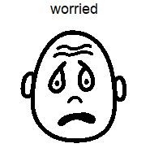



**Achieving**

[](http://hub.careinspectorate.com/improvement/care-inspectorate-programmes,-projects-and-publications/our-creative-journey/creative-examples-materials/active/)

**I celebrate these festivals…**

**Food I like to eat…**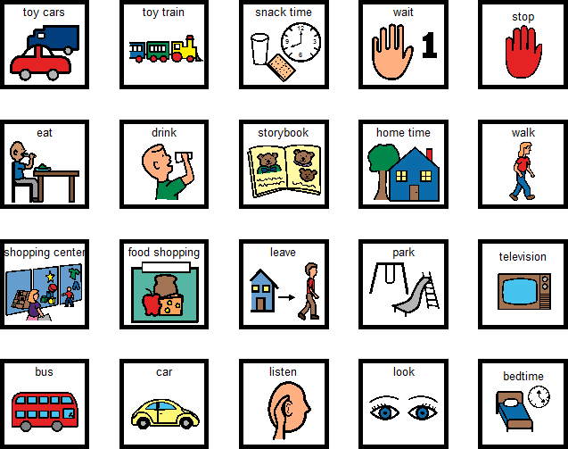

**Active**

[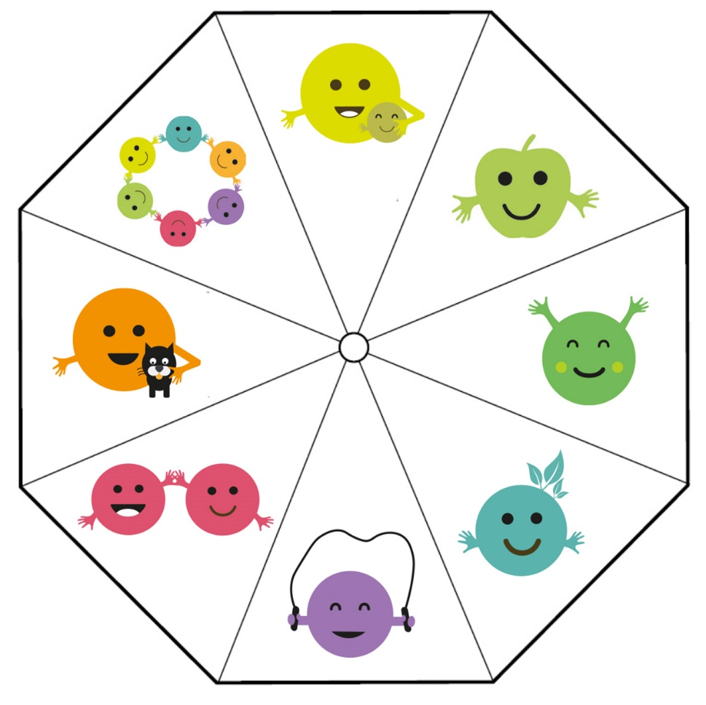](https://www.google.com/url?sa=i&url=https://hub.careinspectorate.com/how-we-support-improvement/care-inspectorate-programmes-and-publications/our-creative-journey/&psig=AOvVaw2M9icY6krfKzMUlZYUVR3B&ust=1633784216614000&source=images&cd=vfe&ved=0CAYQjRxqFwoTCLCai9HuuvMCFQAAAAAdAAAAABAE)

**Responsible**

**Parent/carer signature…**

**Date…**

**Date:**

**I would also like to share…**

**Food I don’t like…**

**Groups/clubs I go to…**

**I may need help with…**

**Included**

**Respected**